Workshop: Enhancing Peer Advising Skills
Sindia M. Rivera-Jiménez, Ph.D., Assistant Professor, Department of Engineering Education
Rivera.jimenez@eng.ufl.edu | riverajimenez.com | TheEngineeringProfessor.org

Activity #1: Defining Advising
- Take a moment to silently reflect on a memorable advising experience you've had, whether as an advisor or an advisee.
- Think about the context of the interaction, the role of the advisor, and the outcome of the interaction.
- Consider what made the advising experience significant or memorable to you.

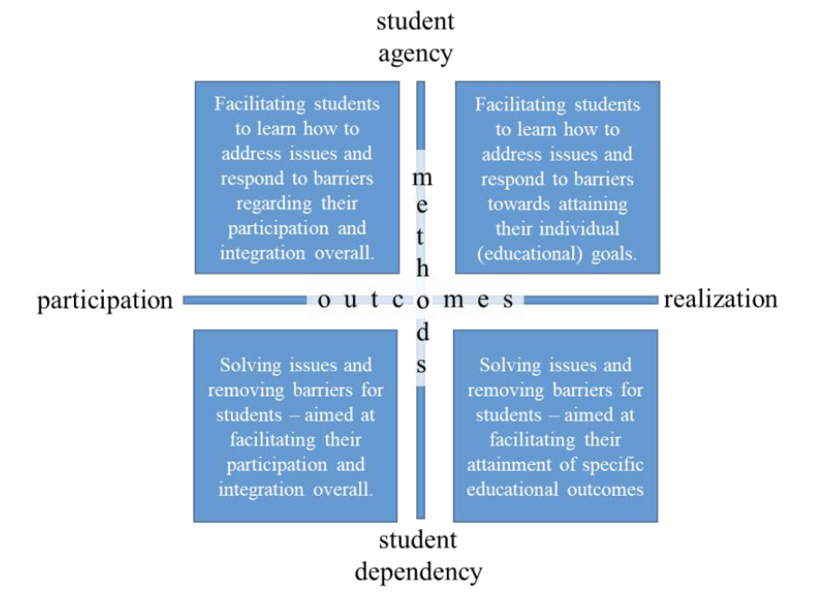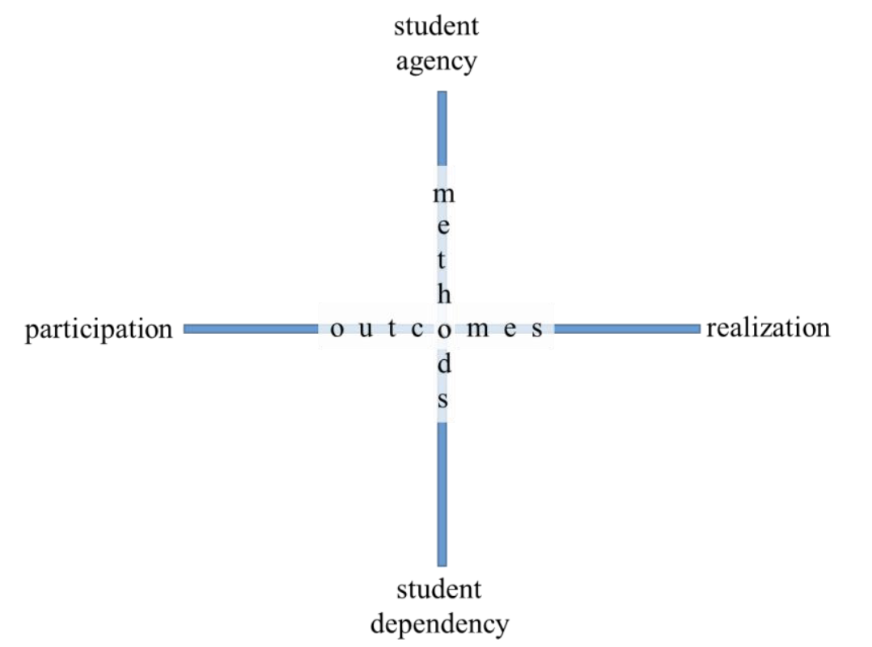

Activity #2: Final Reflection
Step 1: List Interventions, Goals, and Role (Formal/Informal)

Step 2: Reflect on your vision.
- Do we have a coherent vision of advising?
- Are we predominantly caring or teaching through our advising?
- Are we caring (or teaching) the appropriate issues (or are we pampering or abandoning our students)?
- What do we see as (the boundaries of) our individual and institutional responsibilities?
- How connected is our advising to disciplinary learning and teaching?
- Is there mostly congruence or divergence between the perspectives and expectations of various stakeholders?
- To what extent are perspectives a matter of transparency and clear communication?
- Which aspects of our advising do we want to strengthen and develop further?

Step 3: Take Action!
- Select at least one intervention to improve or develop.

